# oVirt安装体验（CentOS 7.2）

mnstory.net

ovirt是redhat支持的QEMU管理UI，本次安装主要是想体验不同的管理软件。

主要根据文章<http://jensd.be/550/linux/install-ovirt-on-centos-7>来安装，安装结果基本能用，但是错误比较多。

## 安装软件

本机节点IP是200.200.103.61，我设置本机的hostname为cent7。

[root@localhost ~]# echo -e "200.200.103.61 cent7\n" >> /etc/hosts

然后安装软件

[root@localhost ~]# yum install http://resources.ovirt.org/pub/yum-repo/ovirt-release36.rpm

[root@localhost vm]# wget http://mirrors.aliyun.com/centos/7.2.1511/isos/x86_64/CentOS-7-x86_64-Minimal-1511.iso

[root@localhost ~]# yum -y install ovirt-engine

根据提示配置软件

[root@localhost ~]# engine-setup

[ INFO ] Stage: Initializing

[ INFO ] Stage: Environment setup

Configuration files: ['/etc/ovirt-engine-setup.conf.d/10-packaging-jboss.conf', '/etc/ovirt-engine-setup.conf.d/10-packaging.conf']

Log file: /var/log/ovirt-engine/setup/ovirt-engine-setup-20160519144409-m14ol7.log

Version: otopi-1.4.1 (otopi-1.4.1-1.el7.centos)

[ INFO ] Stage: Environment packages setup

[ INFO ] Yum Downloading: base/7/x86_64 (0%)

[ INFO ] Stage: Programs detection

[ INFO ] Stage: Environment setup

[ INFO ] Stage: Environment customization

--== PRODUCT OPTIONS ==--

Configure Engine on this host (Yes, No) [Yes]:

Configure VM Console Proxy on this host (Yes, No) [Yes]:

Configure WebSocket Proxy on this host (Yes, No) [Yes]:

--== PACKAGES ==--

[ INFO ] Checking for product updates...

[ INFO ] No product updates found

--== ALL IN ONE CONFIGURATION ==--

--== NETWORK CONFIGURATION ==--

Host fully qualified DNS name of this server [localhost.localdomain]: cent7

[WARNING] Host name cent7 has no domain suffix

[WARNING] Failed to resolve cent7 using DNS, it can be resolved only locally

Setup can automatically configure the firewall on this system.

Note: automatic configuration of the firewall may overwrite current settings.

Do you want Setup to configure the firewall? (Yes, No) [Yes]: no

[WARNING] Host name cent7 has no domain suffix

[WARNING] Failed to resolve cent7 using DNS, it can be resolved only locally

[WARNING] Host name cent7 has no domain suffix

[WARNING] Failed to resolve cent7 using DNS, it can be resolved only locally

--== DATABASE CONFIGURATION ==--

Where is the Engine database located? (Local, Remote) [Local]:

Setup can configure the local postgresql server automatically for the engine to run. This may conflict with existing applications.

Would you like Setup to automatically configure postgresql and create Engine database, or prefer to perform that manually? (Automatic, Manual) [Automatic]:

--== OVIRT ENGINE CONFIGURATION ==--

Application mode (Virt, Gluster, Both) [Both]:

Engine admin password:

Confirm engine admin password:

[WARNING] Password is weak: WAY 过短

Use weak password? (Yes, No) [No]: yes

--== STORAGE CONFIGURATION ==--

Default SAN wipe after delete (Yes, No) [No]:

--== PKI CONFIGURATION ==--

Organization name for certificate [Test]: c^H^H

--== APACHE CONFIGURATION ==--

Setup can configure apache to use SSL using a certificate issued from the internal CA.

Do you wish Setup to configure that, or prefer to perform that manually? (Automatic, Manual) [Automatic]:

Setup can configure the default page of the web server to present the application home page. This may conflict with existing applications.

Do you wish to set the application as the default page of the web server? (Yes, No) [Yes]:

--== SYSTEM CONFIGURATION ==--

Configure an NFS share on this server to be used as an ISO Domain? (Yes, No) [Yes]:

Local ISO domain path [/var/lib/exports/iso]:

Please provide the ACL for the Local ISO domain.

See the exports(5) manpage for the format.

Examples:

- To allow access for host1, host2 and host3, input: host1(rw) host2(rw) host3(rw)

- To allow access to the entire Internet, input: *(rw)

For more information, see: http://www.ovirt.org/Troubleshooting_NFS_Storage_Issues

Local ISO domain ACL: *()^H

Local ISO domain name [ISO_DOMAIN]: sol

--== MISC CONFIGURATION ==--

--== END OF CONFIGURATION ==--

[ INFO ] Stage: Setup validation

[WARNING] Cannot validate host name settings, reason: resolved host does not match any of the local addresses

--== CONFIGURATION PREVIEW ==--

Application mode : both

Default SAN wipe after delete : False

Update Firewall : False

Host FQDN : cent7

Engine database secured connection : False

Engine database host : localhost

Engine database user name : engine

Engine database name : engine

Engine database port : 5432

Engine database host name validation : False

Engine installation : True

NFS setup : True

PKI organization : c

NFS export ACL : *()

NFS mount point : /var/lib/exports/iso

Configure local Engine database : True

Set application as default page : True

Configure Apache SSL : True

Configure VMConsole Proxy : True

Engine Host FQDN : cent7

Configure WebSocket Proxy : True

Please confirm installation settings (OK, Cancel) [OK]:

[ INFO ] Stage: Transaction setup

[ INFO ] Stopping engine service

[ INFO ] Stopping ovirt-fence-kdump-listener service

[ INFO ] Stopping websocket-proxy service

[ INFO ] Stage: Misc configuration

[ INFO ] Stage: Package installation

[ INFO ] Stage: Misc configuration

[ INFO ] Initializing PostgreSQL

[ INFO ] Creating PostgreSQL 'engine' database

[ INFO ] Configuring PostgreSQL

[ INFO ] Creating/refreshing Engine database schema

[ INFO ] Creating/refreshing Engine 'internal' domain database schema

[ INFO ] Upgrading CA

[ INFO ] Creating CA

[ INFO ] Setting up ovirt-vmconsole proxy helper PKI artifacts

[ INFO ] Setting up ovirt-vmconsole SSH PKI artifacts

[ INFO ] Configuring WebSocket Proxy

[ INFO ] Generating post install configuration file '/etc/ovirt-engine-setup.conf.d/20-setup-ovirt-post.conf'

[ INFO ] Stage: Transaction commit

[ INFO ] Stage: Closing up

[ INFO ] Restarting nfs services

[WARNING] Unable to start NFS service or its dependencies: Failed to start service 'nfs-server' Please check their configuration and manually restart

--== SUMMARY ==--

[ ERROR ] Could not refresh NFS exports (1: [u'exportfs: /etc/exports.d/ovirt-engine-iso-domain.exports:1: syntax error: bad option list'])

SSH fingerprint: a5:69:f1:ea:7f:6d:27:01:93:26:89:a4:66:86:de:b6

Internal CA 8D:60:E6:43:F3:D0:E7:9E:D1:B2:0E:92:F7:44:32:7E:17:B8:71:EA

Note! If you want to gather statistical information you can install Reports and/or DWH:

http://www.ovirt.org/Ovirt_DWH

http://www.ovirt.org/Ovirt_Reports

Web access is enabled at:

http://cent7:80/ovirt-engine

https://cent7:443/ovirt-engine

Please use the user 'admin@internal' and password specified in order to login

In order to configure firewalld, copy the files from

/etc/ovirt-engine/firewalld to /etc/firewalld/services

and execute the following commands:

firewall-cmd --permanent --add-service ovirt-postgres

firewall-cmd --permanent --add-service ovirt-https

firewall-cmd --permanent --add-service ovirt-fence-kdump-listener

firewall-cmd --permanent --add-service ovirt-websocket-proxy

firewall-cmd --permanent --add-service ovirt-nfs

firewall-cmd --permanent --add-service ovirt-http

firewall-cmd --permanent --add-service ovirt-vmconsole-proxy

firewall-cmd --reload

The following network ports should be opened:

tcp:111

tcp:2049

tcp:2222

tcp:32803

tcp:443

tcp:5432

tcp:6100

tcp:662

tcp:80

tcp:875

tcp:892

udp:111

udp:32769

udp:662

udp:7410

udp:875

udp:892

An example of the required configuration for iptables can be found at:

/etc/ovirt-engine/iptables.example

--== END OF SUMMARY ==--

[ INFO ] Starting engine service

[ INFO ] Restarting httpd

[ INFO ] Restarting ovirt-vmconsole proxy service

[ INFO ] Stage: Clean up

Log file is located at /var/log/ovirt-engine/setup/ovirt-engine-setup-20160519144409-m14ol7.log

[ INFO ] Generating answer file '/var/lib/ovirt-engine/setup/answers/20160519150418-setup.conf'

[ INFO ] Stage: Pre-termination

[ INFO ] Stage: Termination

[ INFO ] Execution of setup completed successfully

我配置的时候，我的输入中断不支持回退，所以下面参数配置时输入错误，导致NFS启动不了：

[root@localhost vm]# cat /etc/exports.d/ovirt-engine-iso-domain.exports

/var/lib/exports/iso *()

修改一下：

[root@localhost vm]# vi /etc/exports.d/ovirt-engine-iso-domain.exports

[root@localhost vm]# cat /etc/exports.d/ovirt-engine-iso-domain.exports

/var/lib/exports/iso *(rw)

再启动NFS：

[root@localhost vm]# systemctl list-units | grep nfs

proc-fs-nfsd.mount loaded active mounted NFSD configuration filesystem

var-lib-nfs-rpc_pipefs.mount loaded active mounted RPC Pipe File System

nfs-config.service loaded active exited Preprocess NFS configuration

● nfs-server.service loaded failed failed NFS server and services

nfs-client.target loaded active active NFS client services

[root@localhost vm]# systemctl restart nfs-server.service

[root@localhost vm]# systemctl status nfs-server.service

● nfs-server.service - NFS server and services

Loaded: loaded (/usr/lib/systemd/system/nfs-server.service; enabled; vendor preset: disabled)

Active: active (exited) since 四 2016-05-19 15:07:08 CST; 6s ago

Process: 28584 ExecStart=/usr/sbin/rpc.nfsd $RPCNFSDARGS (code=exited, status=0/SUCCESS)

Process: 28581 ExecStartPre=/usr/sbin/exportfs -r (code=exited, status=0/SUCCESS)

Main PID: 28584 (code=exited, status=0/SUCCESS)

CGroup: /system.slice/nfs-server.service

5月 19 15:07:08 localhost.localdomain systemd[1]: Starting NFS server and services...

5月 19 15:07:08 localhost.localdomain systemd[1]: Started NFS server and services.

## WEBUI

按照上面安装完成，可以访问WEBUI：http://cent7/ovirt-engine/

用户名：admin

密 码：engine-setup时设置的密码

### 添加主机

由于只有一台主机，主机又是管理机器又是实际做任务的机器，所以先把本机加入集群，进入管理页面后，左树依次展开找到“主机”，然后“新建”，填入本机参数（我的防火墙禁止了的，所以就不自动配置防火墙了）。

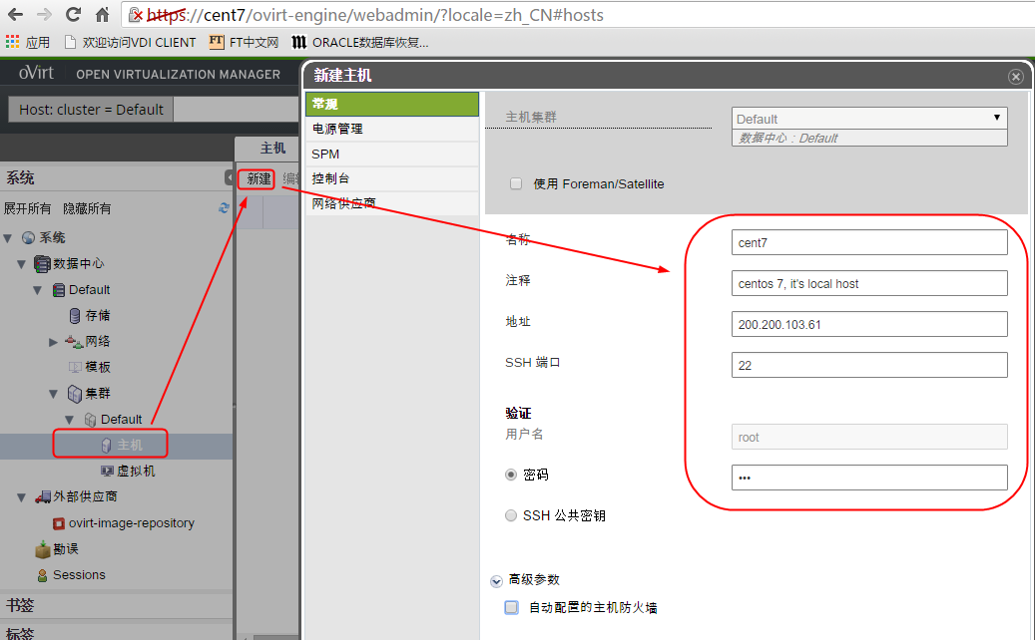

我的安装完后，失败了，状态一列显示：Install Failed，在点击“激活”变成了No Operational，点击“网络接口”/“设立主机网络”,为其分配网络后，状态变为UP。

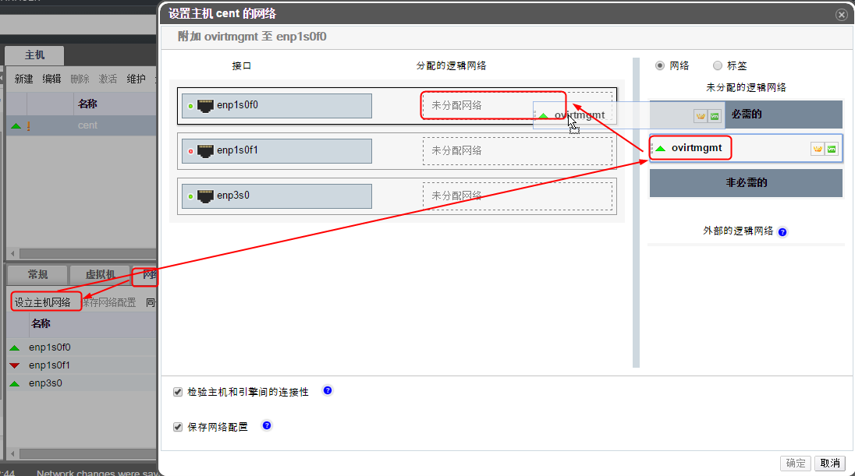

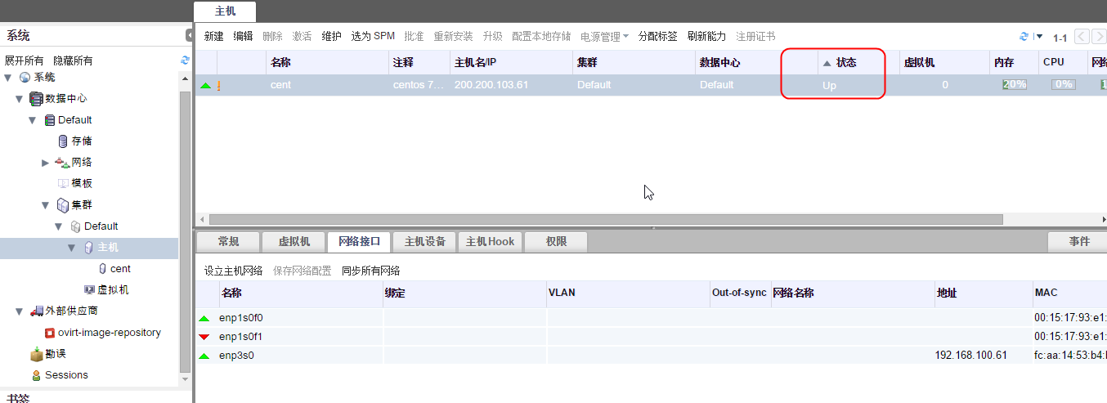

### 添加存储

没有额外的存储，简单起见，用本地目录做NFS：

[root@cent7 ~]# mkdir -p /srv/ovirt/{iso,export,sata,ssd}

[root@cent7 ~]# cat /etc/exports

/srv/ovirt/iso cent7(rw,sync,no_subtree_check,all_squash,anonuid=36,anongid=36)

/srv/ovirt/sata cent7(rw,sync,no_subtree_check,all_squash,anonuid=36,anongid=36)

/srv/ovirt/ssd cent7(rw,sync,no_subtree_check,all_squash,anonuid=36,anongid=36)

/srv/ovirt/export cent7(rw,sync,no_subtree_check,all_squash,anonuid=36,anongid=36)

[root@cent7 ~]# showmount -e

Export list for cent7:

/var/lib/exports/iso *

/srv/ovirt/export cent7

/srv/ovirt/ssd cent7

/srv/ovirt/sata cent7

/srv/ovirt/iso cent7

chown -R vdsm:kvm /srv/ovirt/

chmod -R 770 /srv/ovirt/

systemctl start {nfs-server,nfs-lock,nfs-idmap}

systemctl enable {nfs-server,nfs-lock,nfs-idmap}

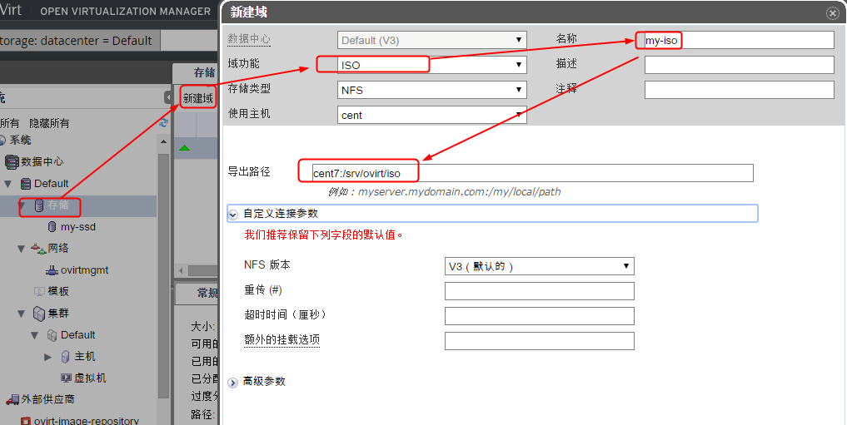

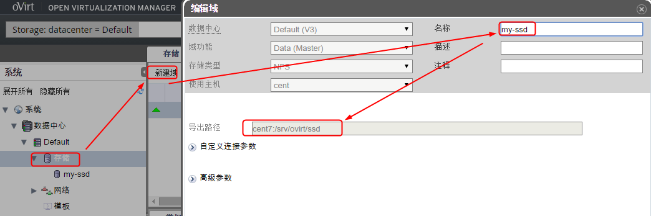

### 上传ISO镜像

[root@cent7 ~]# engine-iso-uploader list

Please provide the REST API password for the admin@internal oVirt Engine user (CTRL+D to abort):

ERROR: Problem connecting to the REST API at https://cent7:443/api

[ERROR]::oVirt API connection failure, (56, 'Received HTTP code 502 from proxy after CONNECT')

我的环境安装后有问题，不过，可以我发现可以将ISO直接MOVE到/srv/ovirt/iso下面的UID/images/UID子目录下面，前端就能看见：

[root@cent7 iso]# tree /srv/ovirt/iso/

/srv/ovirt/iso/

├── 910d77fa-a054-43d4-bad6-12b2e19b2574

│   ├── dom_md

│   │   ├── ids

│   │   ├── inbox

│   │   ├── leases

│   │   ├── metadata

│   │   └── outbox

│   └── images

│   └── 11111111-1111-1111-1111-111111111111

│   ├── CentOS-7-x86_64-Minimal-1511.iso

│   └── WINXP.iso

└── __DIRECT_IO_TEST__

4 directories, 8 files

此时刷新页面就可以看到上传的ISO了：

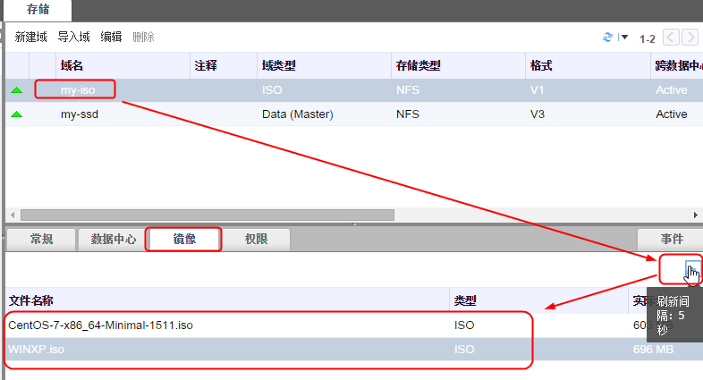

### 新建虚拟机

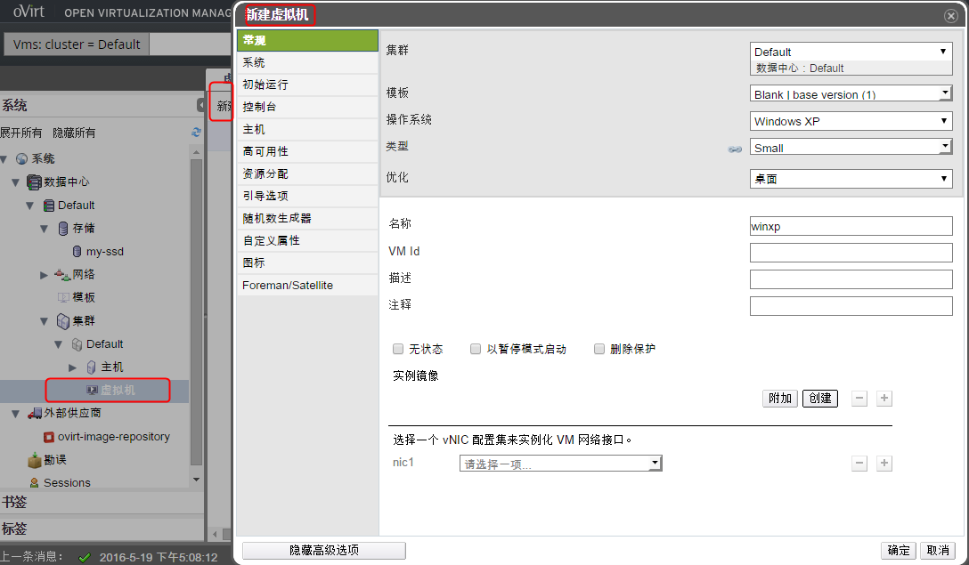

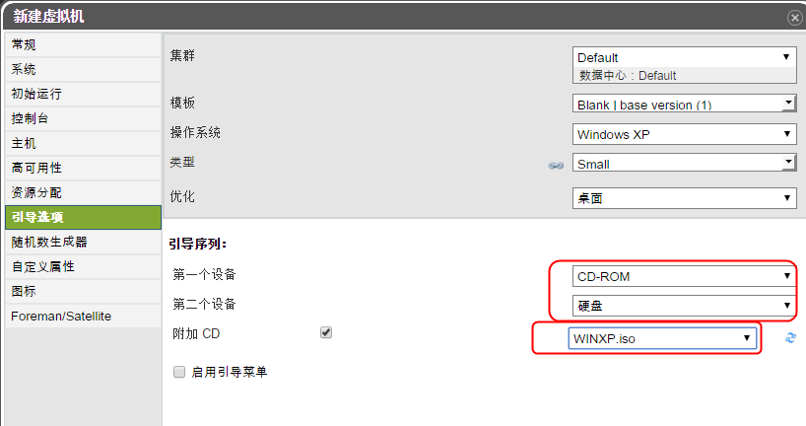

虚拟机建起来，本人的环境VNC失效，没有看到图形界面。但是基本的UI功能体验了一遍，功能不多，比我们的软件做的差。

## 参考资料

1. Install oVirt on CentOS 7 <http://jensd.be/550/linux/install-ovirt-on-centos-7>
2. 小日本的，参照他的图解决了status不为up的问题

<http://qiita.com/ine1127/items/942ddd57b514f10e5127>

2016/5/23